**PIR array in indoor localization and tracking**

**Related works:**

[1][Review PIR 2024](https://drive.google.com/file/d/1xKqLf4gihFYCF0Fw8NXP5qZtApHjVsYo/view?usp=drive_link)

[2][Localization and Tracking using PIR](https://drive.google.com/file/d/1k75oxWVwO1Eo2Nf0flLhpSCmt18WXeUq/view?usp=drive_link)

**Purpose of the project**: The project aims to use a passive infrared sensor (PIR) array to detect humans, track, and define indoor localization. It is related to pre-processing signals which include collecting data and manual labels, using machine-learning (ML) algorithms and tinyML on PIR. At the end of the project, compare the accuracy and the stability of the system in real life.

**Tasks:**

1. Learn about **Python**
2. Learn about PIR characteristics and the way to collect the data.
3. Design a PIR array to collect data.
4. Set up to collect the analog data with the scenarios in [2] and compare the data collected with data public in [2], identify the working area.
5. Propose the localization and tracking algorithms with input analog signals.
6. Experiment and assess the accuracy of the system in simulating real life with the proposed algorithm.
7. Summarizing to be a scientific document.

**Project scope**: skills in pre-processing,self-solving problems, and analysis. Besides, manipulate algebra in the reality task.

**Requirements:**

***Technical requirements:***

1. Know Python, some skills such as analyzing objects, self-study, and using Python libraries.
2. Understand the PIR characteristics and system pipeline.
3. Analyze the task and find solutions for it.
4. Apply tinyML on the system and experiment.
5. Write a scientific report summarizing the project.

***Other requirements:***

1. Report with teachers following the teacher’s timeline to keep track of the project and answer questions from students.

**The timeline of the project:**

* ***Stage 1:***
* Require the students to design a PIR array

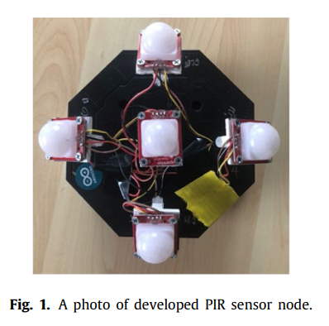



* Set up the scenarios to collect analog data and define the working area.

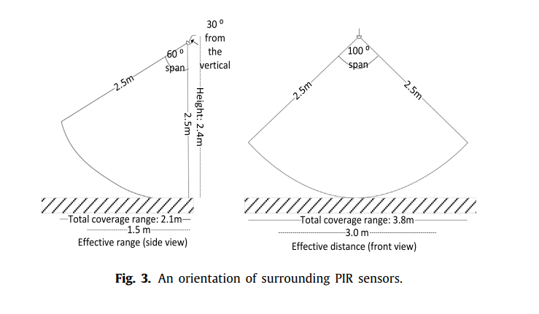



* Visualize analog signals from sensors

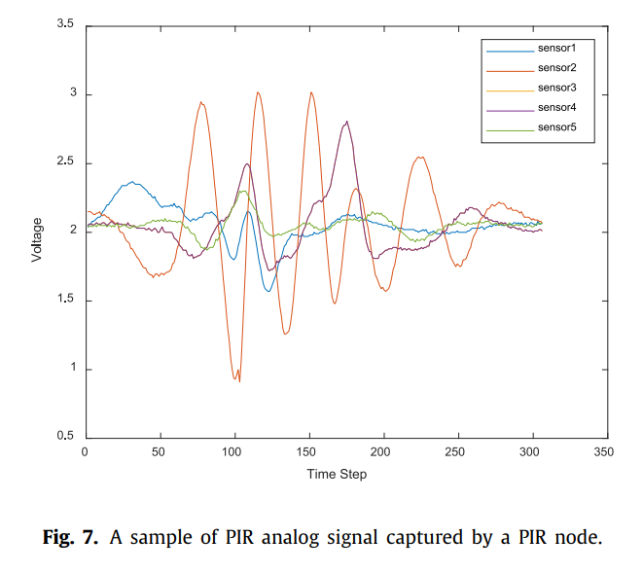



* ***Stage 2:***
* Deployment of proposed ML algorithms by using data which is collected in Project 1 to define indoor localization and tracking.
* Tasks that need to be done: 5 in the Tasks part above.
* ***Final Stage:***
* Complete the system by applying tinyML
* Experiment and improve the system.
* Tasks that need to be done: 6,7 in the Tasks part above.